**Chapter 3**

**Entity-Relationship Diagram**

An entity–relationship model (or ER model) describes interrelated things of interest in a specific domain of knowledge. A basic ER model is composed of entity types (which classify the things of interest) and specifies relationships that can exist between [entities](https://en.wiktionary.org/wiki/entity) (instances of those entity types).

In [software engineering,](https://en.wikipedia.org/wiki/Software_engineering) an ER model is commonly formed to represent things a business needs to remember in order to perform business processes. Consequently, the ER model becomes an abstract [data model,](https://en.wikipedia.org/wiki/Data_modeling) that defines a data or information structure which can be implemented in a [database,](https://en.wikipedia.org/wiki/Database) typically a [relational database.](https://en.wikipedia.org/wiki/Relational_database)

Entity–relationship modelling was developed for database and design by [Peter Chen](https://en.wikipedia.org/wiki/Peter_Chen) and published in a 1976 paper. However, variants of the idea existed previously. Some ER models show super and subtype entities connected by generalization-specialization relationships, and an ER model can be used also in the specification of domain-specific [ontologies.](https://en.wikipedia.org/wiki/Ontology_(computer_science))

An ER diagram is a means of visualizing how the information system produces is related.

Following are the components of ER Diagram

**1. Entity:**

An entity is an object or component of data. An entity is represented as rectangle in an ER diagram.

For example: In the following ER diagram we have two entities Student and College and these two entities have many to one relationship as many students study in a single college. We will read more about relationships later, for now focus on entities.

**2. Attribute:**

An attribute describes the property of an entity. An attribute is represented as Oval in an ER diagram. There are four types of attributes: Simple, Composite, Multivalued, Derived

**3. Relationship:**

A relationship is represented by diamond shape in ER diagram, it shows the relationship among entities. There are four types of relationships.

1. **Actions:**

Actions are represented by diamond shapes, shows how two entities share information in the database.

1. **Connecting Lines:**

Solid lines that connects attributes to show the relationship of entities in the diagram.

1. **Cardinality:**

Cardinality specifies how many instances of an entity of an entity relate to one instance of another entity. Ordinality is also linked closely to Cardinality.

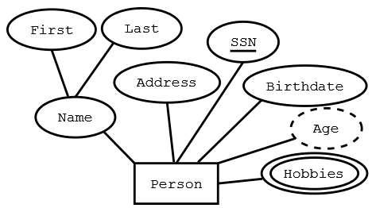

Figure 3.1. Graphical Representation of E-R Diagram. (Courtesy: Wikipedia)

Entity Relationships and Semantic modelling:

**Semantic model**

A semantic model is a model of concepts, it is sometimes called a "platform independent model". It is an intentional model. At the latest since [Carnap,](https://en.wikipedia.org/wiki/Rudolf_Carnap) it is well known that:

"...the full meaning of a concept is constituted by two aspects, its intension and its extension. The first part comprises the embedding of a concept in the world of concepts as a whole, i.e. the totality of all relations to other concepts. The second part establishes the referential meaning of the concept, i.e. its counterpart in the real or in a possible world".

**Extension model**

An extensional model is one that maps to the elements of a particular methodology or technology, and is thus a "platform specific model". The UML specification explicitly states that associations in class models are extensional and this is in fact self-evident by considering the extensive array of additional "adornments" provided by the specification over and above those provided by any of the prior candidate "semantic modelling languages ["UML as a Data](http://www.tdan.com/view-articles/8589) [Modelling Notation, Part 2"](http://www.tdan.com/view-articles/8589)

**Entity–relationship origins**

Peter Chen, the father of ER modelling said in his seminal paper:

"The entity-relationship model adopts the more natural view that the real world consists of entities and relationships. It incorporates some of the important semantic information about the real world."

In his original 1976 article Chen explicitly contrasts entity–relationship diagrams with record modelling techniques:

"The [data structure diagram](https://en.wikipedia.org/wiki/Bachman_diagram) is a representation of the organization of records and is not an exact representation of entities and relationships."

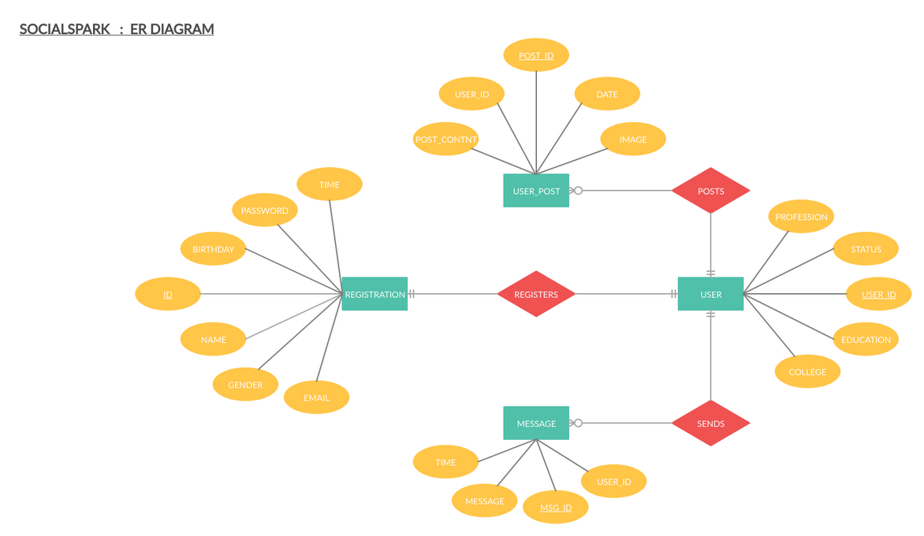

**E-R Diagram – SOCIAL SPARK**